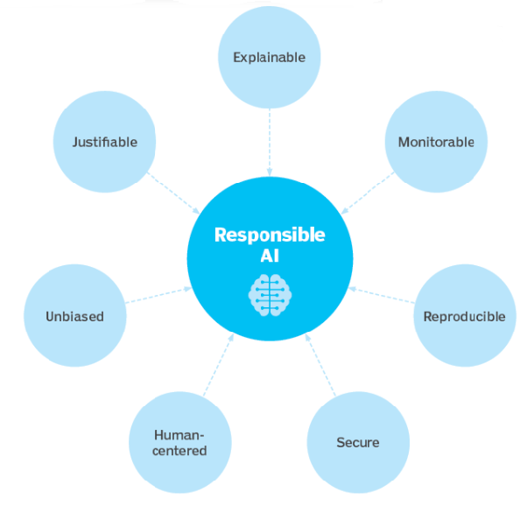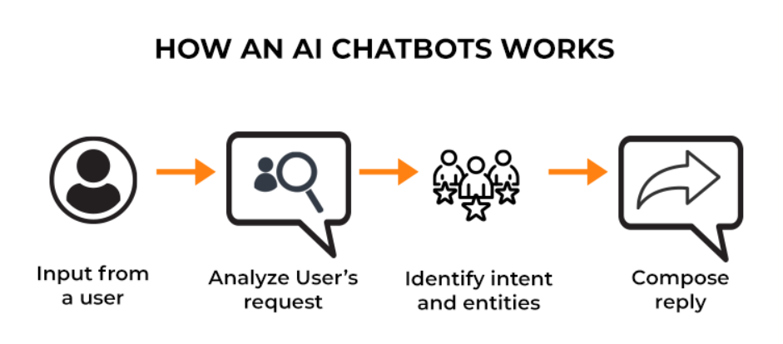

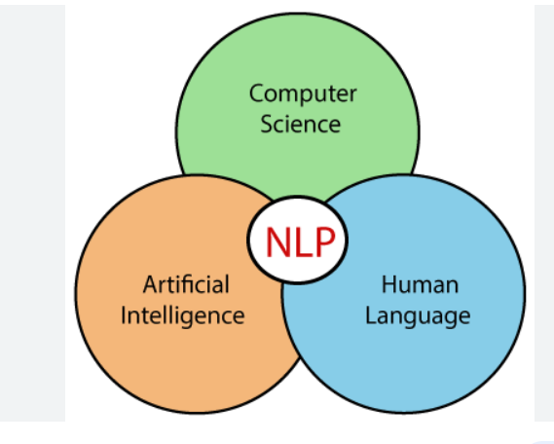**My words on AI:**

**AI is the part of everyday life. AI is the technology which completely change the 21st century.**

When machines somehow act like humans, takes decisions and behaves and judge like a human this process is called Artificial Intelligence. This is also called simulation of human brain.

Machines means largely Computer systems, smart mobile phones, Alexa, Siri, ‘Ok Google’ etc.

**Application of AI are** – Expert System, Natural Language processing, speech recognition & Machine vision.

**Expert System:** A piece of S/w which uses datasets of expert individual or expert analysis, true, real result paved by expert person or expert knowledge to offer advice or decision. Mostly used in medical sciences.

{ES are intended to complement (Kamipana bharun kadhane), not replace to humans.??}

**Natural Language Processing (NLP):** NLP is giving the ability to computers, machines to understand speech, spoken words, text like human beings can.

**Chatboat**  is uses NLP to create human like conversation.



NLP gives the ability to computers to interpret, manipulate, and comprehend human language.

We can use SaaS Tool to implement NLP

**Speech recognition:** here user explain himself/ herself in voice/speech format or verbally to a device.

E.g. : Alexa, Siri, Google assistance, cortana, <- these are virtual assistance

It is use for dictation also.

**Machine Vision** : means Machine vision technology gives the ability to industrial equipment to “**See**”.

**MV** used for visual inspection, defect detection, multiple cameras, identification, sorting, tracking products, and basis on this taking rapid decisions based on what it sees.

Now a days, there is a hype around the AL has accelerated hence vendors have been scrambling to promote how their product & services using it. Often, they called it as AI but that is only a simply a component of AI like machine learning, not the entire AI. AI requires foundation of hardware & software to write & train the machine learning algorithm. Python, R, C++, java, Julia, these are the languages use in AI development/ developing the AI applications.

**How AI work?**

**Data is the food for AI/ AI machines, devices.**

In general, AI system ingest the large amount of labelled training data, And analyse this data, find correlation (to find the mutual relationship or connection between two data sets) in between and learn/ study the pattern of the data. Basis on this pattern, it makes predictions for future states. It predicts the decision for future. Or can say it forecast the future prediction.

**Examples of AI:** Well know examples of it, **first** is **Chatbots** : Chatbots response like a lifelike agent to end users, like on e-commerce sites we use chatbots, the electronics devices communicate with us.

Chatbots are computer programs which replicate and analyses the human dialogues in written and spoken format. Chatbots enabling humans to communicate with electronics devices like they are conversing with human agent.



**Second** example **: Image identification tool**, this tool identify and describe an object in images by reviewing millions of examples (Available in respective dataset).

This technology identifies, written text, images, objects, human faces and other information in images.

Like **Google Lens.**



**AI focuses on cognitive skills, these are as mentioned below:**

1. **Learning:** In this aspect of AI focuses on acquire large amount of data and create rules ***to generate valuable information***. And these rules are called **Algorithm**. The algorithm provides to computing devices with step by step instruction to perform specific task.
2. **Reasoning :** In this aspect focus on choosing the right algorithm to get the desire outcome.
3. **Self Correction:** In this aspect of AI programming, Learn from its own mistake or feedback, or from punishment – not following correct path, and then correct it acquire the corrected path, pattern. Algorithm continuously work on it to follow the same path, and provide most possible accurate results/ predictions. This is self-correction.
4. **Creativity :** In this aspect of AI, it predict new result from the old data or pattern. It predicts the result for new data set from the old pattern. This uses neural network, statistical methods and other AI techniques to generate new text, new images, new music and new ideas.

**It predicts output, without being explicitly programmed to do so.**

**Machine Learning : In this** , it uses historical data as input & predict new output value.

**Deep Learning :** It is a subset of m/c learning. It is based on our understanding of how human brain is structure.

Use of artificial neural network structure is the underpinning of Deep learning. E.g. of it, self-driving cars. ChatGPT.

**Why Artificial Intelligence is important?**

Now a days, AI has become potential factor to change our life, lifestyle, how we live, work, play etc. It has been used in business to automate the task done by humans. AI supports the humans to get the job done effectively, faster and more creative. AI is a complement to humans. It is used in customer service work, fraud detection & quality control. In short, AI can perform task much better than humans particularly when it comes to repetitive task, details-oriented task, such as analysing large number of documents, legal documents to ensure all fields are filled in properly etc.

Now a days, AI is the central/ core part of every big and successful organization like Microsoft, Google, Mata. Where AI support in improve outcomes & outpace the competitors.

**Types of AI : - Based on Capabilities : there are 3 stages:**

1. **Weak AI :** Can not work without human interaction Known **as Narrow AI**

Perform very specific task. Narrowly define set of specific task. At this stage machines don’t poses any thinking ability, they just perform a set of pre-defined functions.

e.g. Siri, Alexa, Sophia, the self-driving cars, AlphaGo (A computer program that play a board game ) and etc.

Almost all the AI based systems that are built till this date are fall under the category of weak AI or Artificial Narrow intelligence.

1. **Strong AI:** Can work without human interaction known as **AGI** – **Artificial General Intelligence : This** replicate the cognitive abilities of human brain. When unfamiliar data has given still it can produce the output, find the solution autonomously. This is yet not achieved. Research is going on AGI application. This state of AI thinks & analyse like human brain. Here, it has capability of taking decision, solve complex problems and recognize objects exactly like human.

Machine will poses the ability to think & make decisions just like human beings. They are currently no existing E.gs of strong AI, but its believe that we will be soon able to build machines that are as smart as human beings. Strong AI are actually considered a threat to human existence by many scientists**.**

**Stephen Hawkins said that**, the development of full AI will take the full charge. And could spell the human race.

1. **Artificial Super Intelligence : This state of AI has capacity of surpass the human capability.**

ASI, currently seen as hypothetical situation. As depicted in movies- machines are taken over the world. However, this stage is not exist.

**Types of AI : Based on Functionality : there are 4 types**

1. **Reactive AI :** It has no memory & task specific. **E.g. Deep Blue** is a super computer who beat Garry Kasparrov in chess. Which is IBP product. Deep blue can identify piece on the chess board & make predictions, but it has no memory so the past experiences cannot save for future reference. This machines react only on the present data and take into the consideration only the current situation.
2. **Limited Memory :** It has limited memory or temporary memory to store past experiences are used for future decisions/ future evaluate actions. E.g. Self-driving cars.
3. **Theory of Mind :** It is a psychological term. Here, system would have social intelligence to understand emotions. In this type, system infer human intensions & predict behaviour.
4. **Self-** **Awareness** : In this type, system have self-sense and consciousness. / self aware.

**Advantages & Disadvantages of AI:**

**Advantages :**

* **Good at detail oriented jobs**
* **Reduce time for data heavy tasks** : E.g. : banking and securities, pharma and insurance, to reduce the time it takes to analyse big data sets. Financial services:-> to detect fraud
* **Saves labour and increases productivity:**
* **Can improve customer satisfaction through personalization**
* **AI-powered virtual agents are always available**
* **Delivers consistent results**

**Disadvantages :**

* **Expensive**
* **Requires deep technical expertise**
* **Limited supply of qualified workers to build AI tools**
* **Reflects the biases of its training data, at scale**
* **Lack of ability to generalize from one task to another**
* **Eliminates human jobs, increasing unemployment rates**

Though AI can work on large amount of data very quickly & effectively, simultaneously it is expensive too.

**Application of AI / Sphere of influence of AI :**

1. **Healthcare**
2. **Entertainment & Media**
3. **Medical sciences**
4. **Automobiles, Manufacturing**
5. **Business**
6. **Education**
7. **Finance**
8. **Law**
9. **Security**
10. **Banking**
11. **Transportation**

**Ethical AI:** Use of AI tools are everywhere now a days, enormously research is going on in this field. But the question is, it is for betterment or it is going to be worse for humans and their exitance?

This can be problematic because machine learning algorithm which is the underpin of many of the AI tools are work on data given for training. And human selects which data used to train the model/ AI program. ML has potential to predict and it may misuse, so it need to be monitor closely. Also generated predictions, decisions using AI tools are bias too.

In the industries that operate under a strict regularity compliance, explainability is a problematic stumble block for them. Because for them it is compulsory to explain how the decision arrived. **It is called black box. meaning you have no visibility into how the machine learns and makes decisions.**

E.g. In USA, in financial institutes, they have to explain their decision for credit issue. But when the decision of rejection of is taken by AI programming, however it is difficult to explain how the decision was arrived. This inability of explainability, when this decision-making process can be explain called black box AI.

AI's ethical challenges include the following: bias, due to improperly trained algorithms and human bias; misuse, due to deepfakes and phishing; legal concerns, including AI libel and copyright issues; elimination of jobs; and data privacy concerns, particularly in the banking, healthcare and legal fields.

**Responsible AI:**



**AI Governance & Regulations** : Like mentioned earlier, Lending regulations require financial institutions to explain credit decisions to potential customers. This limits the lenders to use the deep learning algorithm. Because these algorithms are not opaque & lack of explaninability.

The European Union's General Data Protection Regulation ([**GDPR**](https://www.techtarget.com/whatis/definition/General-Data-Protection-Regulation-GDPR)) is considering AI regulations. GDPR's strict limits on how enterprises can use consumer data already limits the training and functionality of many consumer-facing AI applications.

White House Office of Science and Technology Policy (**OSTP**) guides businesses on how to implement ethical AI systems.

**Evolution of AI:**

**History of AI:**  goes back to classical ages

**Talos** : Greek mythology : Machines and mechanical man who well thought of, program to guard one of the island of crete from invadors.

In Greek mythology, was a giant automaton made of bronze( Animated bronze warrior) to protect Europa(Europa was a female) in crete from pirates & invaders.

**19 Century:**

**1950 :** Alan Turing : proposed a turing test, basically a turing determine whether a computer can intelligently think like a human being or not? The turing test is the first serious proposal in the philosophy of AI.

**1951 : This era is know for games of AI: Game Era : chess & checkers**

**1954 :** IntroduceFirst industrial robot **Unimate** by George Devol which was sold to General Motors.

**1956 : John Mc Carthy first coin the term Artificial Intelligence – mark of most imp era for AI**

This was followed by first AI laboratory which is set up in 1959, MIT AI lab was set up – for research of AI.

**1960 :** First Robot was introduce by general Motor assembly line. (ref to 1954)

**1961** : A first **chatbot** was introduce by IBM named as **Eliza.** In **1994,** the term coin as **“Chatterbot”.**

**1997**: IBM’s supercomputer deep Blue defeated the world’s no. 1 chess player Garry Kasparov in the game of chess.

**2005**: Marks of year autonomous robotic car called **Stanley**. Created by Stanford University’s Stanford racing team.

**2011**: IBM’s **Watson** Question-Answering machine defeated two world’s champion

n Brad ratter & Ken Jennings

**There is exponential growth in it’s potential.**

AI cover domain such as Machine learning, Deep learning, neural network, NLP, knowledge Base, expert system and so on.

AI is a science & engineering of making intelligent machines. Development of a computer system which are capable of perform a task that require a human intelligence such as decision making, object detection, solving complex problems and so on.

**11-08-2023**

**Different or different branches of Domains OF AI: for solving real world problem in order to solve any problem:**

1. **Machine learning :** Interpret, process & analyse data:

**Types of M/c Learning** :

**Supervised learning**

**Unsupervised learning**

**Reinforcement learning**

1. **Deep learning :** process of implement of neural networks on high dimensional data to get insights & find solutions. It is basically logic behind face verification algorithm on fb, self-driving cars, Siri, Alexa
2. **Natural language processing:** drawing insights of natural human languages in order to communicate with machines. Eg. Twitter uses NLP to detect Foul languages, does sentiment analysis, Amazon uses NLP to understand customer review and improve their experience.
3. **Robotics:** is a branch of AI , which focus on different branches an application robots. E.g.: Sophia- Artificial agent
4. **Expert system:** AI based system, that learns and reciprocate the decision-making ability of human expert.

E.g: Used in Information management, fraud detection, virus detection, managing medical & hospital record.

1. **Fuzzy logic:** This rules-based programming. This is heuristic approach. This work on Boolean values

e.g. in Medical fields, automating gyre system in our car etc.

**Why AI is the word’s new electricity now?**

**Why AI is important : It has capacity to improve accuracy & decision making.**

When the electricity invented, we started using it initially for basic need then for facilities & to live a luxuries life.

After a few days’ electricity became essential part of human life. Each & every devices, appliances, vehicles we are using required electricity. We can see, after a few days, we will be watching only electric vehicles are running on the road. Today we can’t think of a single day, not even an hour without electricity. That means we have rigours dependency on electricity, it became basic need, necessity for human beings.

Similarly, in today’s technical world, technical era, AI becoming the essential part of human beings’ life. Knowing, unknowing we are using AI based applications, devices, appliances every day, every hour of our life. We are not only using AI in our vehicles but after a few days the AI based cars/ vehicles will run on the roads. Means a driver would not require to drive a car, a human being would not require to drive a car. Drivers will be replaced by artificial Intelligence. Even we can say AI would be more essential part of the human beings’ life compare to electricity.

So, this technical era will be known for new electricity **Artificial Intelligence.**

**Why Ethical AI is the need of the world?**

As we are aware, AI has better decisions capasity ofcourse based on the data provided by humans but sometimes the decisions are bias, unfair, distinct. So these data have been collected by legal ways as well as illagaly & unethically. That means AI using some private data, which is unethical. So we need truely data protection policy. If we are creating an account on any social media, we fill our personal details as well as professional details also. And these organizations share infact sale this data to other organizations without the consent of customers. These companies use these data for their business development, marketing, strategic planning, a few organizations are dishonestly use this data and so on. Simultaneoously a few companies trap the coustomers, cheat them, they lay a trap by using their personal information just sake of a few amount of money , etc. And it's a threat for our security, safety.

E.g. Facebook shares our personal as well as all the uploaded information with a few other Inc.

A taxi app ask for the permission of our gallary, contact list, location and etc. And to go ahead we do not read the T&C, we directly gives the persion to access it. However, they do not require this much information to install & use the app. This is same with a few other app as well. This unethical. Our life is getting recor digitall. Hence there is a rigorous need of ethical AI.

Where, Our privacy is our fundamental rights. DPDP (Digital Personal Data Protection) bill has passed on 11th Aug 2023.

But At the end this is our responsibility also like not to share our details on social media, do not allow the access of our contact list , gallery and other app's access in mobile phones. By allowing this we are giving them right to acess our all the data whaich is available in our phones.

Also, ethical AI is require to avoid bias decisions, ensuring privacy od users & their data. By applying codes of ethics in the companies & govrenment – led regularitory, these are the two way AI ethics can be implemented. Governance is required to implement ethical AI and to keep the humans and humanity safe and secure.

**5 Components of AI :**

1. Learning
2. problem Solving
3. perception
4. using languages

AI work on 3Cs : Comparison, Computation, Cognition

**Terminology & related concept of AI : AI is Data- Driven Domain**

Machine learning is a sub-fiels or a type of AI. Machine leaning is a data driven technique, means it learn and develop itself from provided data. It acquire the large amount of data. Analysis it, co-relate it , find the pattern in it and predict the output basis on the past experiences. Basically it learn a function, train the model and predict outcomes.

ML also reffered as Predictive modelling or predictive analytics.

“**Machine Learning**” term coined by **Arthur Samuel** in 1959. ML defined as Ability of computer to learn without explicitely/ specifically programmed. ML has freedom to learn independently. Or ML allow computers to learn autonomously without the intervention or assistance of humans.

**How Does Machine Lerning work?**

As mentioned earlier, ML is an application of AI which enable systems to learn & improve from past experiences, without being explicitely programmed for it.

Like, our brain, human brain gain knowledge & understand it, learn from past experiences & we improve our performance, forecast decisions. Similarly in ML also, ingest the large amount of data, learn from it, find the co-relation in it, depict patterns in it, i.e. it learn from past experiences, improve themselves, improve their result, predict more accurate results, decisions. ML is dependent on inputs as training data, knowledge graphs to understand the entities & connections in between them. Goal of the ML is enable companies to replace or augment certain human capabilities in the industries. Algorithm drives the machine learnig. We provide data as a input to machine learning called as “**training data**”. ML algorithm build a mathematical model based on this training data and it takes decisions or predict results without being explicitely programmed to do so. And this concept work aotobomously. Means Learn more and more with the experiences, No need to program for it separately. Common machine learning application the real world are chatbots, self driving cars, speech recognitions.

**Why is machine learning important??**

The concept of machine learning is around us since long time. Today, every human beng is using this concept knowingly -unknowingly. The scientist Arthur Samuel first designed a computer programm for playing checkers. The more the program played the game, the more program will learn from experience. And more the program will become expert in it. Practice makes program perfect. ML has the capicity of perform any task very speedly & single human brain can not copy the same scale. Hence ML is important. Now a days, machine learning is widely adopted. In 2021, as a result of pandemic 41% companies accellerate AI applications. Adoption of AI at this edge, speed up the year, AI-ML applications/technologies. Specially in hospitality, entertainment, agriculture, mamnufacturing and trasnportation industries. AI-ML is became a lifeblood.

**ML used in -**

**Data Security :**ML model can identify safety of data before it turn into breaches. By observing the past experiences, ML mathematical model predict the high -risk activities so that the risk can be mitigate/minimize.

**Finance:** Banks, Treding brokers, & Fintech firms are using ML algoriths to provide best solution or advice to investors and automate the treding.

**Helthcare**: In this area, ML use huge amount of health care data to analyze the disease, discovery of treatment and cure. It improve patients outcomes & to set routine pocesses to avoid human error.

**Fraud Detection:** In real time, AI-ML is being use to detect frauds & anamalous activities, specially in Banking & finance firms.

**Retail:** Here, Using ML algorithms developers, researchers offers the relevant product to customers basis on the buyer's past experiences, past purchase, even basis on geographical & demographic data. It helps to retain the potential customers & to provide them best service experience. Though model learn from past experience, as we fed new data to algorithm learn & optimise the function/ operation and it produce most correct output. It always try to improve performance, developing intelligence over a time.

**ML Training methods Or types of ML:**

**Supervised Learning:** In this terminology of machine learning, Supervised learning work on data provided, but this data is Labeled data, structured data and this required supervision.

Here, the output is already known, we just need to map the input to output. Labeled data have been passed to train the machine/model. Labelled data means that the output is already known to us.

Eg. to identify an image of a dog from set of images of animal.

Here, Data-set is prepared by stakeholders and then they pass the data to model for traning purpose. As this data is prepared by stakeholders, it can be less bias and more controlled. Supervised learning, learns from past data and can apply predictions on new data. The algorithm produces an infurred function to predict output values. In supervised learning, machine learn from examples. Operator provide a known data to algorithm i.e. Input and output are already known, algorithm has to find a method to determine how to reached at thode input & outputs or how to arrive at those input—output. Algorithm learns from examples provided by operator, identifies patterns in it, learn from observations and makes predictions. Algorithm makes predictions and it corrected by operator, this process continues till algorithm achieves a level of accuracy.

**It generally used for Classification & regression problems**

**Supervised Learning divided in 3 parts:**

**Classification:** There are classes, classification of observed values, classification of input provided by operator which reflects in form of output. ML program find out the conclusion or predict result basis on the observed values and then it determine to which category new observation belong.

E.g. When we receive an email it observe by supervised learning algorithm and filter it, classify it , basis on content of an email whether the email is spam or an important so If it is spam then it will reflect in spam folder ot it will reflect in inbox.

**Regression:** Regresson means understanding thr relationship between independent & dependent variable, i.e. Relationship between features & outcomes. Once the relationship between independent & dependent variables are estimated then the outcomes can predict.

Let's understand the regression from below example:

The scatter a plot below shows number of students graduated from 2001 to 2012.



Basis on the geaph, what would be the number of graduates in the year 2018? From the observations we can see the number of graduates every year increasing in a linear pattern. So basis on the past data or experience we can assume the the number of graduates in the year 2018 by ploting the same variable from 2001 to 2018. Reference to below graph, we can see our predicted value is approximately same to the actual value.



**This process of fitting a function according to the set od data points is called as regression analysis. R**egression analysis is the most important tool in the machine learning used for predictions. In regression, we fit a function on available data/data – points and try to predict outcomes for future.

This fitting of function serves 2 purposes or we can say it has 2 types:

1. **Interpolation : We can estimate the missing data in the given range.**

Let's assume, we have scatterred, sparse data. Reference to below graph, we have data set for number of college graduates every 4 years.

Now, If I want to find out or estimate number of college graduates in missing years then we will have to draw a line through the available data points. That means fitting a function or line in limited available data this is **interpolation**.



**Above graph shows the interpolation**

1. **Extrapolation: It estimate future data out of the range.**

Let's understand the Extrapolation by assuming we have limited available data/data points, data-set and we have to predict future values from available data. Let's assume we have available data from 2001 to 2012 and we have find out or predict the number of college graduates from 2013 to 2018.

Let's refer below graph:

Here we can see number of college graduate students increasing linearly with the year. So we will fit a line through the avilable data points. i.e. We will fit a line from 1st point to 12th point, then we will extend it for next 6 points, future points. These 6 points are prediction basis on first 12 points. Let's refer below graph:



**Unsupervised Learning :** This learning workd on the unlabeled data, that means there is no fixed output. Here, the model learns from the data & discovers the features & patterns of data. Here supervision not required.

E.g. Identyfy the vehicle whether Bus or a truck from their features like – length & width of the vehicle, the types of vehicle used, front & rear end, roof, etc. Based on thiese the model identifies the vehicle. Ther learn their own and predict the output.

In this learning, unlabeled data has provide as a training data. Algorithm study this data to identify pattern in it. There is no fixed output, algorithm predict the output here basis on identified pattern of data. Here no human operator to provide instructions or to correct the output. Hence we say, no supervision is here. In unsupervised learning , a large amount of data set undergoes trianing and identify patterns, relations-corelations in them. As we pass the unlabeled data for traning, algorithm organise the data so that it form a proper structure, describe a structure. It means, it form a group of similar features called clustering or can say arrange raw data in well organised manner. The system does not know the correct output with certainty. Instead it drwas inferences from provided data-set. Supervised learning has speed & scale.

**It used for clustering & association problems:**

**Clustering:** Clustering means grouping unlabeled data. As it works on unlabeled data means it relies on unsupervised learning. We can say, it is little simillar to **classification** but Clustering does not require labeled data. It works on unlabeled data, and this is the big advantage of use of clustering. Clustering is a process of grouping the similar objects/data in same group. Basis on the features, values, and a few other attributes objects are distibuted in different groups. It is use in data analysis phase to to discover new information & pettern in data. It is use for segmenting the data. It has lot of application in the area of pattern recognition, image analysis, market segmentation, social network analysis. Many broad range of industries are using it like airlines, healthcare.

Let's understand the Clustering from below image.

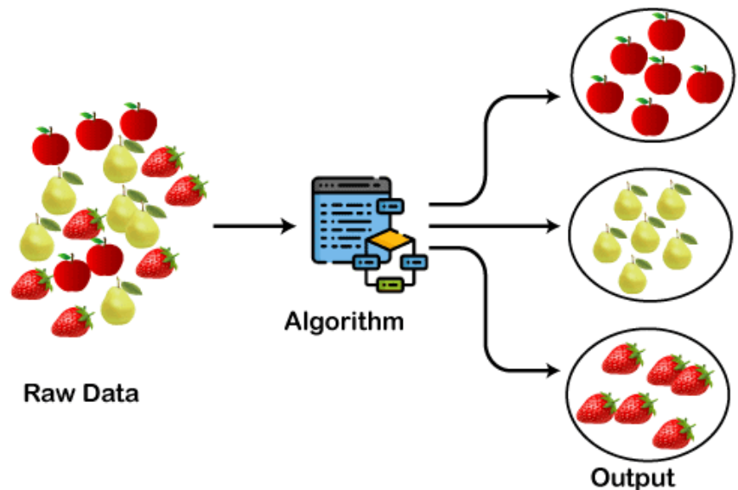**Clustering**

**Clustering Algorithms are:**

1. K-Means
2. MeanShift
3. DBSCAN
4. Hierarchical Clustering
5. BIRCH
6. **Association :** This is rule based method. This method discover relationship in between variables of large dataset. Association is a relation between two different classes which estabilishes through their objects. Association learning is a rule learning technique which checks dependancy of one data item on the another data item and maps accordingly do we will achieve more profit. It is based on the different rules to discover the interesting ralationship among the variables of data sets.

It is used Market basket analysis, web usage mining, etc.

Market basket analysis is use in retail industries to discover the association of items. Let's consider an example – in a supermarket, the products are kept together that are bought together.

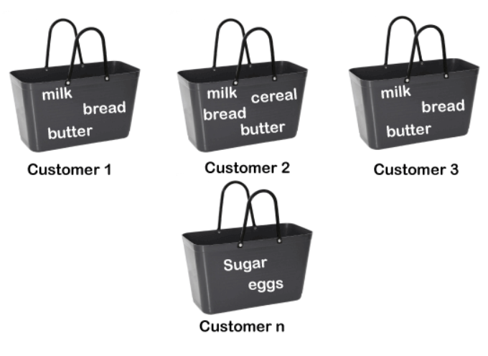 E.g. If a customer buys bread most likely he can also buy butter, jam, eggs, milk, these products are store in a shelf or nearby. Let's have a look on below diagram :

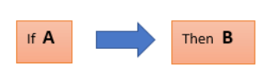**Association Rule work on below concept:**

If element is called as antecedent and then part is called consequent. This kind of relationship between two items is called **cardinality**. If number of data increases the cardinality increases. It is all about creating rules.

**Semisupervised Learning(SSL):** In this learning data set used are both labeled & unlabeled, unlabeled data is more in quantity compare to labeled. Well, we can say marriage of supervised & unsupervised learning techniques is turned to a semi-supervised Learning.

We'll get little idea of SSL from below image :

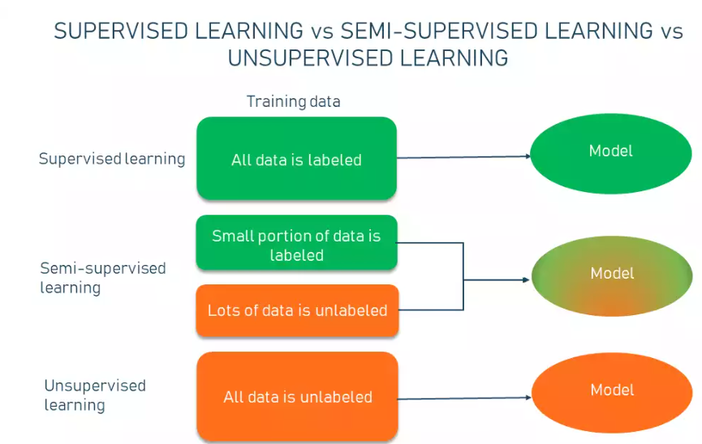

**Here,** initially, model get train on a few amount labeled sample and then iteratively this model apply on the greater number of unlabeled data. SSL work on variety of problems from classification, regression, clustering, association.

As it mentioned earlier, SSL use small amot of labeled data to train & large amount of unlabeled data to apply, which reduces expenses on manual annotation and cut data preparation time.

**Self Training:**

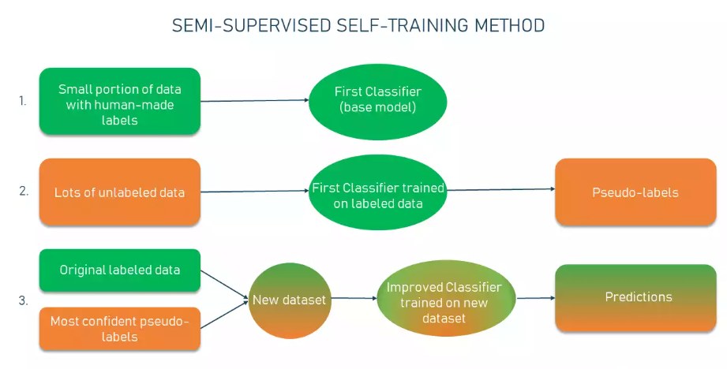

**Reinforcement Learning:** This learning work on two components, agent & an environment. Agent perform an task in the environment, if the agent perform correct task & follow correct path then it will get reward/positive feedback and if the agent performs wrong task or follow incorrect path then it will get penaulty/ negative feedback. So the model learn from it's mistakes. Here supervision not required as it learn from self mistakes. Then the model gradually collects many rewards. It learn through trial & error. With the experience agent will learn to perform correct actions in less time. Here, agent learns autonomously utilizing feedback and no labeled data is used here.

RL is an excellent strategy where decision making is in sequence & making of applications with long term goal. Purpose of RL is to achieve maximum accuracy by obtaining maximum number of awards/ positive feedbacks. The software agent automatically determine the ideal behaviour within the specific context to maximize its performance. A simple positive feedback or a reward is known as a **reinforcement signal**. This signal helps agent to learn which action is best.

E.g. Identify the shape of the objects. Playing chessboard, robotics, etc.

**Key Factors in Reinforcement Learning:**

**Agent:** It is a sole learner & decision maker

**Environment**: It is a physical world where an agent learns & decides the actions to be performed.

**Action**: A list of actions which agent perform.

**State**: The current situation of an agent in the environment.

**Reward**: Each selected action/ positive action of agent, environmentgives a feedback called reward.

**Policy** : Agent prepare strategy to map situations to actions.

**Value Function**: It shows reward achived from starting until policy is executed.

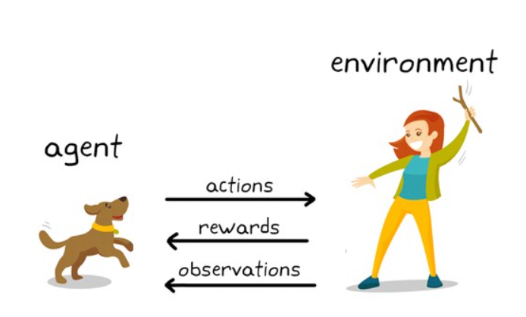

**Here, in the above image what do we observe?**

There is a master consider as an environment, who is training to her dog consider as an agent to catch a stick. She throws a stick towards the dog and dog has to catch it. If the dog get a stick successfully he will get a bone as reward. At the end, dog observe and understand the pattern. As soon as the dog get the stick, he will get bone as a reward earlier from master in a lesser time.

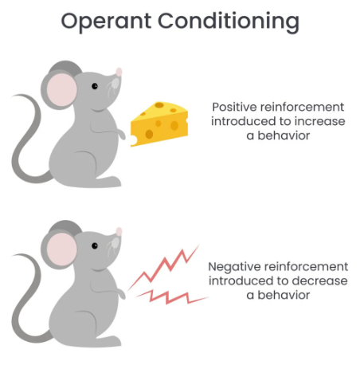

**Two types of Reinforcement Learning:**

1. **Positive Reinforcement Learning:** Posituve reinforcement works on or theory of operant conditioning means it is involvement of change in behaviour by reinforcing or inhibiting effect of its own consequences. It is a form of learning where, a future event is possible but cannot be predicted with certainty. Means contingency in between a specif behaviour & its consequences help in increasing the same behaviour, likelyhood behavior repetition. Reward means leading to a repetition of desired behavior. To encourage the behavior which is desired.

It increases the strength & frequency of behavior.

E.g. Giving a treat to child when she completes her homework.

**Advantages:**

* Maximizes the performance of an action
* Sustain change for longer time

**Dis-advantages:**

* **Excess reinforcement can lead to an overload of states which would minimize the result.**

1. **Negative Reinforcement Learning:**  It is represented as strengthing of behavor. If agent falls under this learning, the negative condition is avoided, it tries to stop this action in the future.

**Practical Applications of reinforcement learning:**

1. Robotics for Industrial Automation
2. Text summarization engines, dialogue agents (text, speech), gameplays
3. Autonomous Self Driving Cars
4. Machine Learning and Data Processing
5. Training system which would issue custom instructions and materials with respect to the requirements of students
6. AI Toolkits, Manufacturing, Automotive, Healthcare, and Bots
7. Aircraft Control and Robot Motion Control
8. Building artificial intelligence for computer games

**Dis-advantages of AI:**

Machine learning is not based in knowledge. Contrary to popular belief, machine learning cannot attain human-level intelligence. Machines are driven by data, not human knowledge. As a result, “intelligence” is dictated by the volume of data you have to train it with.

* Machine learning models are difficult to train. Eighty-one percent of data scientists admit that [training AI with data is more difficult than expected](https://www.expert.ai/blog/overcoming-training-data-roadblocks-with-hybrid-ai/?). It takes time and resources to train machines. Massive data sets are needed to create data models, and the process involves manually pre-tagging and categorizing data sets. This resource drain can create latency and bottlenecks in advancing ML initiatives.
* Machine learning is prone to data issues. Ninety-six percent of companies have [experienced training-related problems with data quality, data labeling and building model confidence](https://content.alegion.com/dimensional-researchs-survey). Those training-related problems are a key reason why seventy-eight percent of ML projects stall prior to deployment. This has created an extraordinarily high threshold for ML success.
* Machine learning is often biased. Machine learning systems are known for operating in a black box, meaning you have no visibility into how the machine learns and makes decisions. Thus, if you identify an instance of bias, there is no way to identify what caused it. Your only recourse is to retrain the algorithm with additional data, but that is no guarantee to resolve the issue.

Black Box is a weakness of ML, means as it unsupervised we can not understand how the decisions have predicted , the pattern has analysed. To overcome this weakness, we can combine ML & symbolic AI. Symbolic AI is a rule base methodology to process data. Symbolic AI is a knowledge based graph, i.e. it is called **open box.** And together symbolic AI & ML form **Hybrid AI**. Through this approach we would be able to understand how data is used, how it processed and how the pattern analysed & how the predictions made. We will get more insight into.

**Artificial Neural Network(ANN):** It is a computational model. It is used in many applications like speech recognition, image recognition, machine translation, natural language processing, and medical/clinical diagnosis. ANN learns from sample data set, this is the significant advantage of it. And from sample data-set ANN discover new pattern.

We know human nervous system made up of neurons. ANN try to emulate human nervous system, so that machines can comprehend stuff & make judgement in sentiment way. Here machines are programmed to function like human neurons, in order to creat Artificial neural Network.